Name ______________________________ Date __________
Pax Romana (“Golden Age of Rome”) Mrs. Valdes

The Pax Romana period lasted from 27 BC to 180 AD and was started during the reign of Augustus. In Latin "Pax" means a time of peace.

I. Architecture
- Romans want greatness and prestige; and to show off their Roman power. Roman examples of this are immense (very large) palaces, temples, and stadiums.
Rome = Really Big Buildings 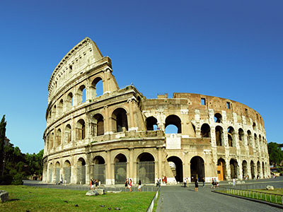

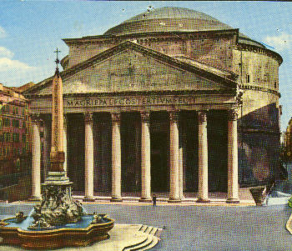
- The Romans borrowed Greek columns for the Pantheon, which was a temple to the gods and also used for governmental meetings.

Rome = Domes and Arches

- Domes were used to build the Pantheon. Domes allowed for roofing over large structures.

- Romans were the first to create arches, 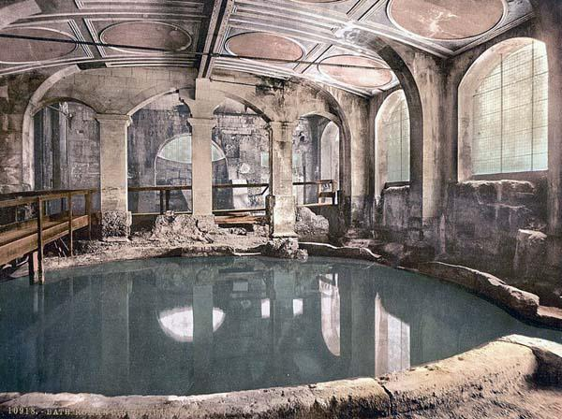were used to help support larger structures.

II. Entertainment
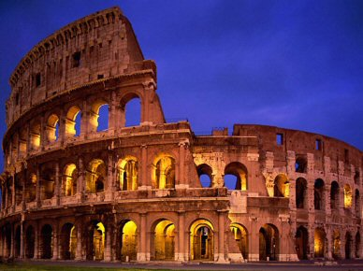

Gladiator contests were held here. Gladiators were slaves trained to fight. Other events such as battles, dramas, and executions were also held here.

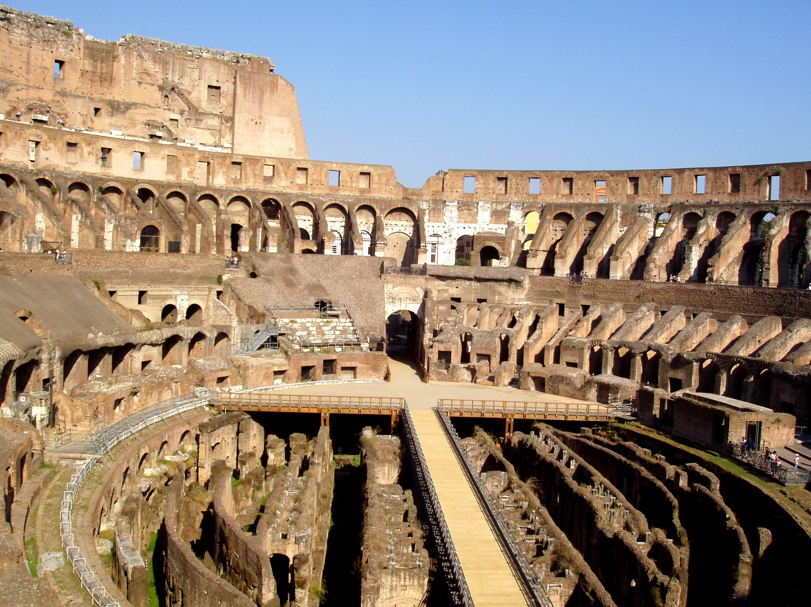 Both diverted attention of the poor to the enjoyment of the games, races, & battles. “This was a way to control a mob!”

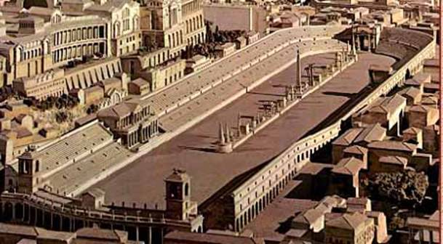 Circus Maximus was Rome’s largest racetrack. Chariot racing was held here. Winners of the races were hailed as heroes!

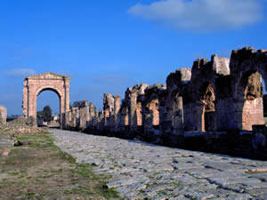
III. Engineering

Roads were originally built and used by the Roman army. “All Roads lead to Rome”
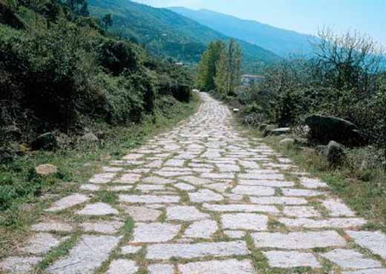
Rome was the capital of the Empire and Roads connected conquered cities back to Rome
-Trade, Transportation and the Roman Army could move faster

Complex roads bring the Roman Empire together. It was said that, “all roads lead to Rome.”

Aquaducts
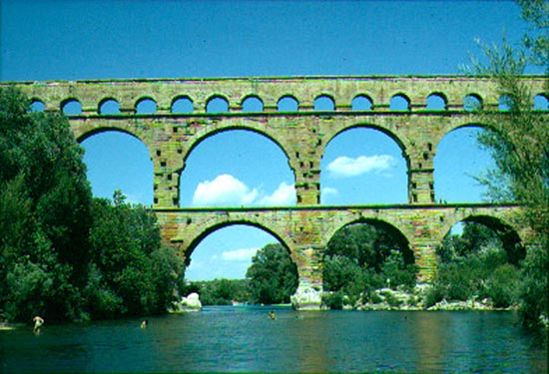 Definition: Bridge like stone channel that brought water from the hills to the city. Only the rich had water piped in. The availability of fresh water was very important to Romans. People would also gather here to wash and hear the latest news and gossip. Clean water helped to keep diseases away
IV. Arts

Romans borrow much of their art from the Greeks.
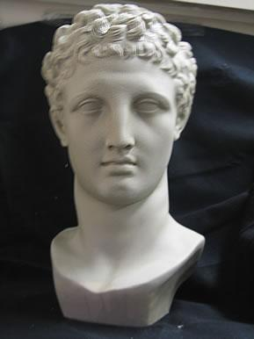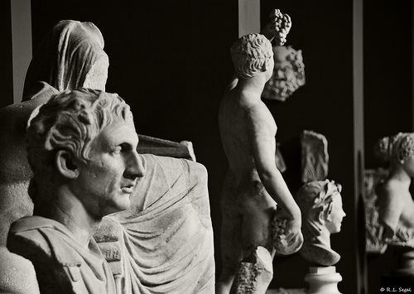

Statues represented the power & leadership of ancient Rome. It was not idealism and perfection like the ancient Greeks. The statutes had expressions and attitude.

Romans adopted “realism” from the Hellenistic civilizations. Romans revealed every aspect of detail no matter if it was good or bad.

V. Science

Greco-Roman civilization was a blend of Greek, Roman, and Hellenistic culture and traditions. Over the course of Pax Romana, Rome absorbed and blended ideas from all areas of the empire. Cultural Diffusion

The city of Alexandria in Egypt continued to be a center of learning. Much of science was left to the Greeks, who were now citizens of Rome.
Pliny the Elder was a Roman scientist who compiled volumes of geography, zoology, botany, and others.

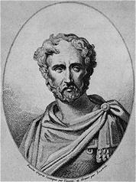

VI. Literature, History, and Philosophy
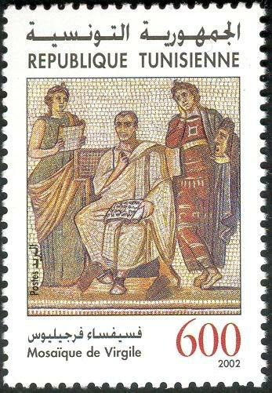 Educated Greeks admired many Roman works. Roman poet Virgil wrote The Aeneid. He hoped to arouse patriotism and unite Rome after many Roman civil wars.
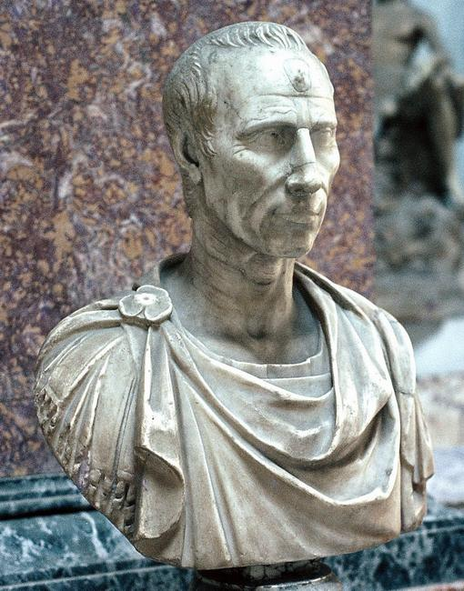

The Roman historian Livy wrote about Rome’s past in order to arouse patriotism as well as tell stories of heroes.

The Romans borrowed philosophical ideas from the Greek and Hellenistic Civilizations. The idea of Stoicism stresses the importance of accepting duty and accepting ones fate.

Lasting influence:

What do you see?


